Women of the Year

# [**The Making of Mariska**](https://www.glamour.com/story/mariska-hargitay-svu-law-order-women-of-year-2021?s=09)

The star of television’s longest-running drama on her real-world purpose

By [Marisa Meltzer](https://www.glamour.com/contributor/marisa-meltzer)

Photography by [Victoria Will](https://www.glamour.com/contributor/victoria-will)

Styled by [Jordan LaValle](https://www.glamour.com/contributor/jordan-lavalle)

November 2, 2021

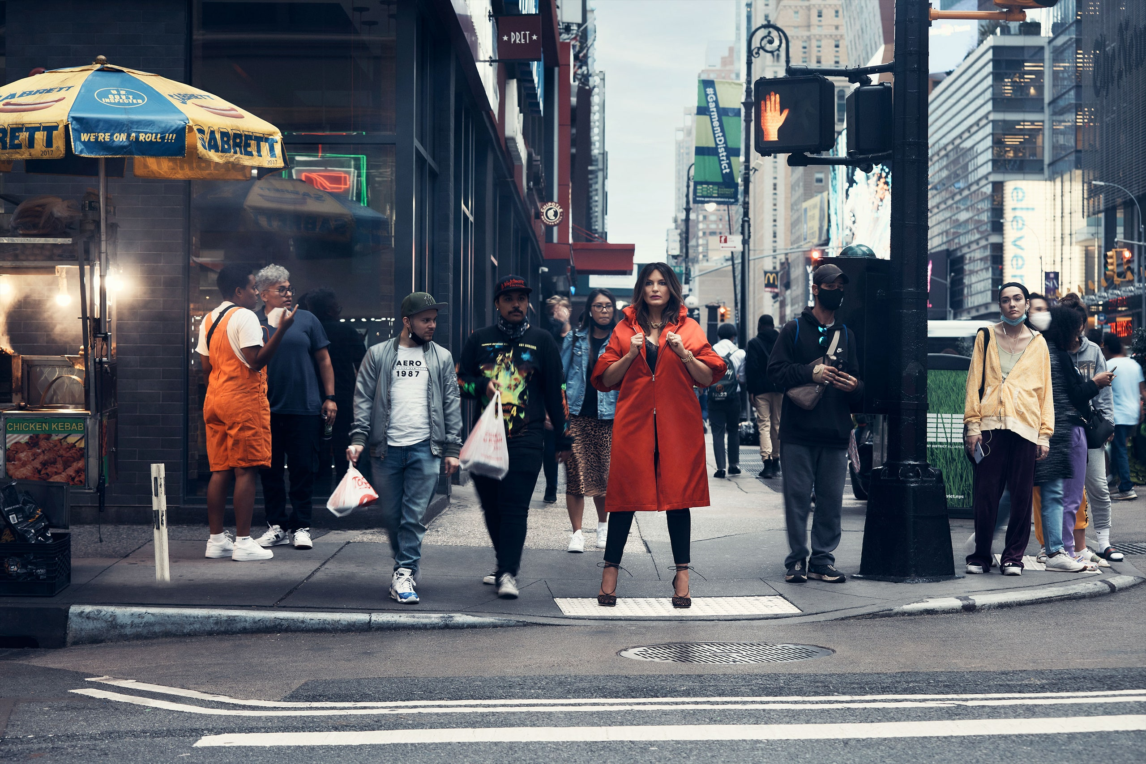

[Dries Van Noten](https://driesvannoten-la.com/) coat. [Theory](https://www.theyes.com/pl/theory/pant/yoke-legging-in-leather-combo-in-black?utm_campaign=13673955579&utm_source=google&utm_medium=adwords&utm_content=530044202838&utm_term=&adgroupid=123740604683&product_id=753925d21c30493184ee02ee82b2cafc-5&gclid=Cj0KCQjwtrSLBhCLARIsACh6RmgdR8lkZigv4rkldef808om8-DNpWW7X9qt_IuNS6KbsCNDkE27AmgaAqMdEALw_wcB) pants. [Brinker and Eliza](https://brinkerandeliza.com/collections/necklaces/products/the-showstopper-necklace) necklace. [Liv Ballard](http://livballard.com/) bracelet.

Mariska Hargitay is good in a crisis. The star of *Law & Order: Special Victims Unit* is sitting in her Upper West Side apartment in New York, exuding the kind of competence and emotional fortitude that tens of millions of people expect from her alter ego. She’s recounting the details of an exhausting summer: health problems (minor), professional accomplishments, friend stuff—all against the backdrop of [a global health crisis](https://www.glamour.com/package/one-year-later-pandemic-stories).

“I felt like an octopus being pulled apart in so many directions,” she says. “Sometimes when you’re in those moments, it’s a lot. And you’re like, ‘How am I going to climb the mountain?’ But here I am today going, ‘It was a kick-ass week.’”

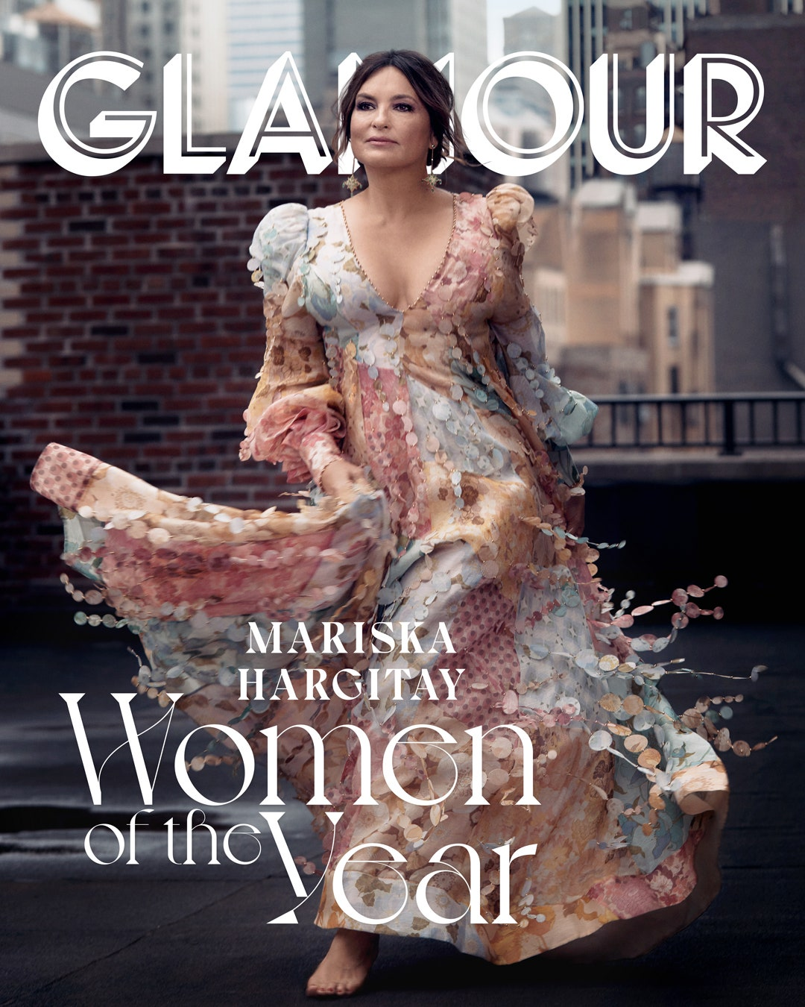

[Zimmermann](https://www.nordstrom.com/s/zimmermann-tempo-patch-long-sleeve-linen-silk-gown/5972500?color=MIXED+PRINT&country=US&currency=USD&utm_channel=low_nd_seo_shopping&utm_source=google&sp_source=google) gown. [Liv Ballard](http://livballard.com/) earrings.

As if on cue, her husband, Peter Hermann, whom she met on the show and married in 2004 and with whom she has three children—August, Amaya, Andrew—comes into the room to see if she’s okay. He apologizes for interrupting, and she explains. “My very, very best friend, soul sister—her father just died last night,” says Hargitay. Her voice starts to crack and tears well up for the first, but not last, time during our conversation. “My first thought was, How fast can I get to JFK? Because she’s just a pure heart.”

That’s who Mariska Hargitay is—a fighter, a protector, a mom, a wife, a star. She’s a 57-year-old multiple Emmy and Golden Globe winner and nominee who is on TV’s longest-running drama. She’s a self-described late bloomer who planned her honeymoon with Hermann in Hawaii so she could attend her Joyful Heart Foundation’s first retreat for survivors of sexual trauma. She is the producer of *I Am Evidence*, a documentary about the crisis of untested rape kits, and is also the namesake—via Olivia Benson—of Taylor Swift’s beloved cat. And her work—not just her record—makes her as relevant now as she was when she first landed onscreen. When Congresswoman Ayanna Pressley, noted progressive and member of the #TheSquad, was asked about her favorite show, she [named](https://twitter.com/ayannapressley/status/1366914044603617287?lang=en) *SVU* and identified herself as a “superfan.” In a tweet-thread [endorsement](https://twitter.com/ayannapressley/status/1366914044603617287?lang=en) of Massachusetts Suffolk County district attorney Rachael Rollins in March 2021, Pressley identified the candidate as “#OliviaBensonGoals.”

ADVERTISEMENT

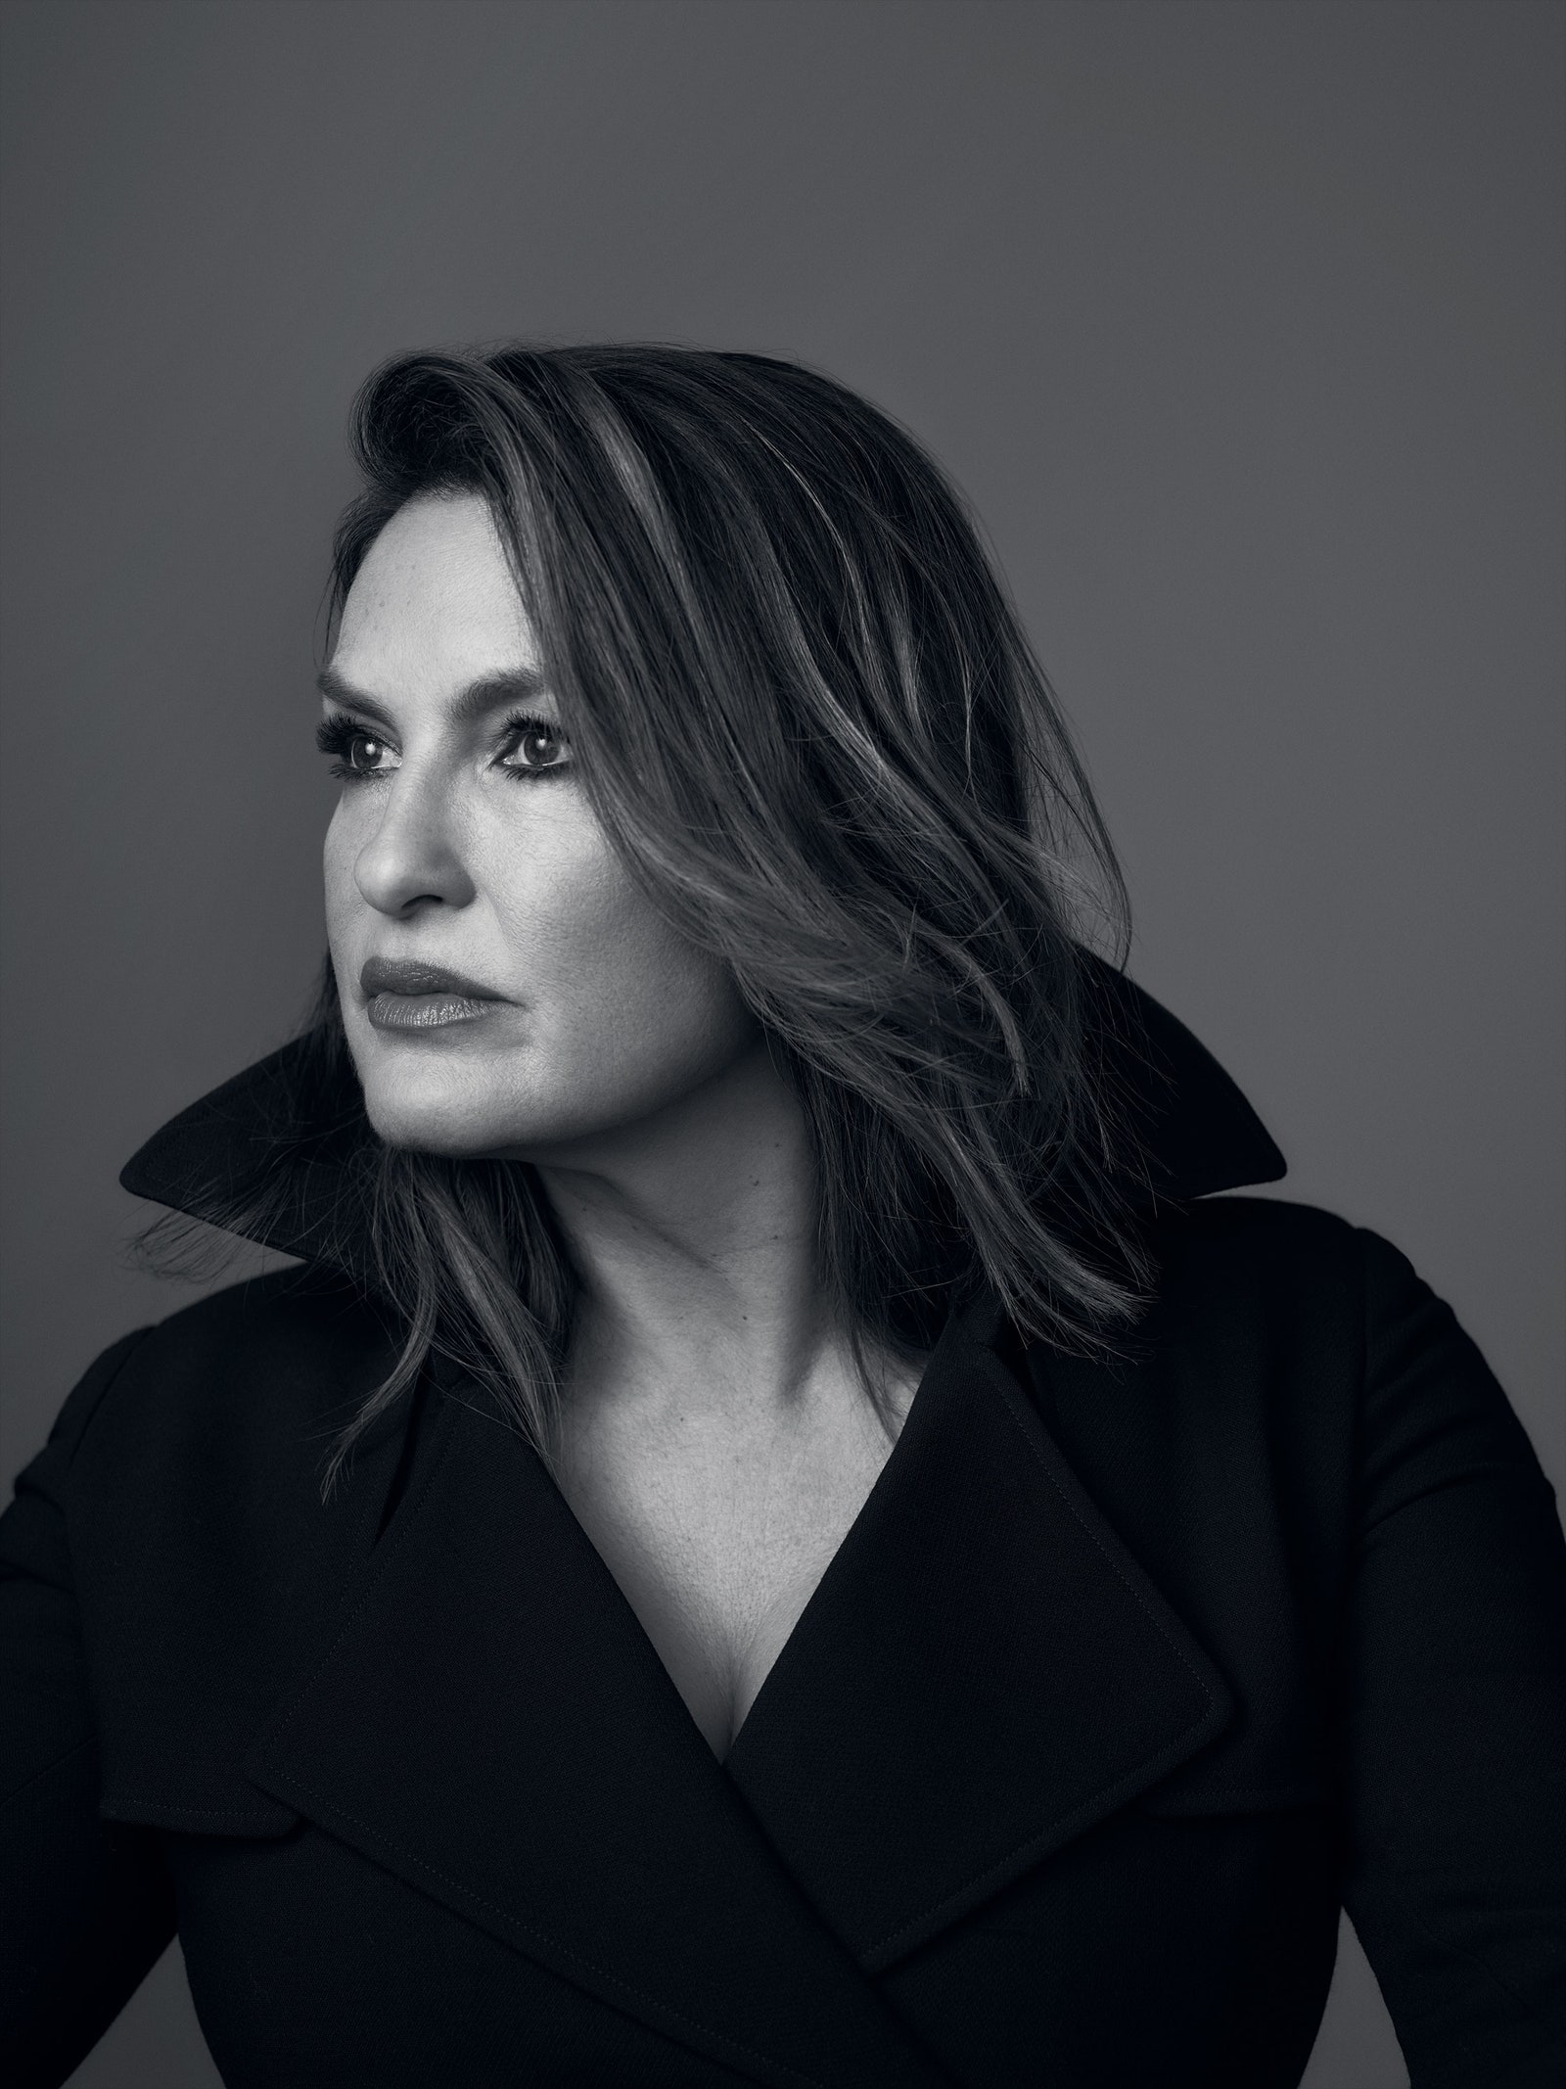

[Gabriela Hearst](http://www.gabrielahearst.com/) coat.

It’s hard to know how much of Hargitay’s grit and resourcefulness was innate and how much was the result of tragic circumstances. She was just three when her mother, the Hollywood star Jayne Mansfield, died in a car accident. Hargitay’s father, Mickey—the former Mr. Universe and an immigrant from Hungary—raised her. Thanks to him, she had a relatively normal childhood: on the swim team, running cross-country, playing volleyball. She was crowned Miss Beverly Hills 1982.

But there was always a sense of how dark life could be. “I think I learned about crisis very young, and I learned very young that shit happens and there’s no guarantees, and we keep going. And then we transform it,” she says, emphasizing each word with her hands. “That’s been kind of my superpower, and the gift of having trauma early in life. I’ve spent the last 50—how old am I?—57, so 54 years sort of trying to figure out what happened and why, and what am I supposed to do with it?”

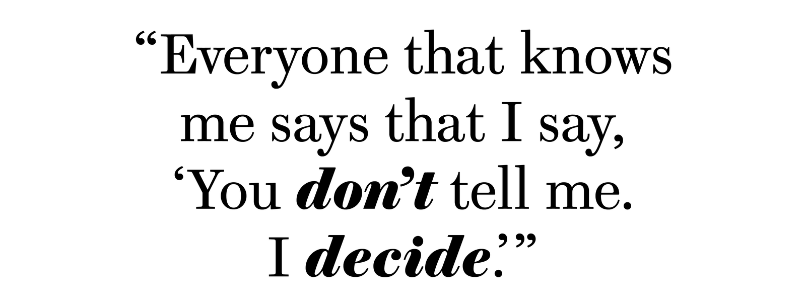

ADVERTISEMENT

She calls it the frozen place—the tightening that happens as a result of trauma, whether it’s sexual assault, domestic violence, or losing a parent. “I clearly was in that frozen place for a lot of my childhood—of trying to survive, actually trying to survive,” she says. “My life has been a process of unpeeling the layers and trust and trusting again.”

The origin stories of Joyful Heart and *I Am Evidence* both come back to that idea of the frozen place. As soon as the first episodes of *Law & Order: SVU* began airing in 1999, she got letters from strangers—hundreds, then thousands—about sexual trauma. The intense fandom of the show is at least in part because of the alternate universe it presents, where victims are not just heard and seen, but triumph. It’s an alluring and cathartic premise, and perhaps why people are so obsessed with the show, even though a pair of white police officers aren’t the most likely American heroes in this age. So many of the sentiments Hargitay heard in letters were the same: “I feel alone,” “I have shame.” Hargitay saw the misplacement, how survivors had taken on “all these things that didn’t belong with them, that belonged with the perpetrator.”

“I went, ‘Oh, no, no, no, no, no, no, no, no, no,’” she remembers. “Joyful Heart was my response. That’s what the foundation has been about—giving back possibility.” She comes back to her preferred metaphor. When something is frozen, “light doesn’t get in.” She launched the foundation to guide people out of those stuck, numb places, to lead them toward hope.

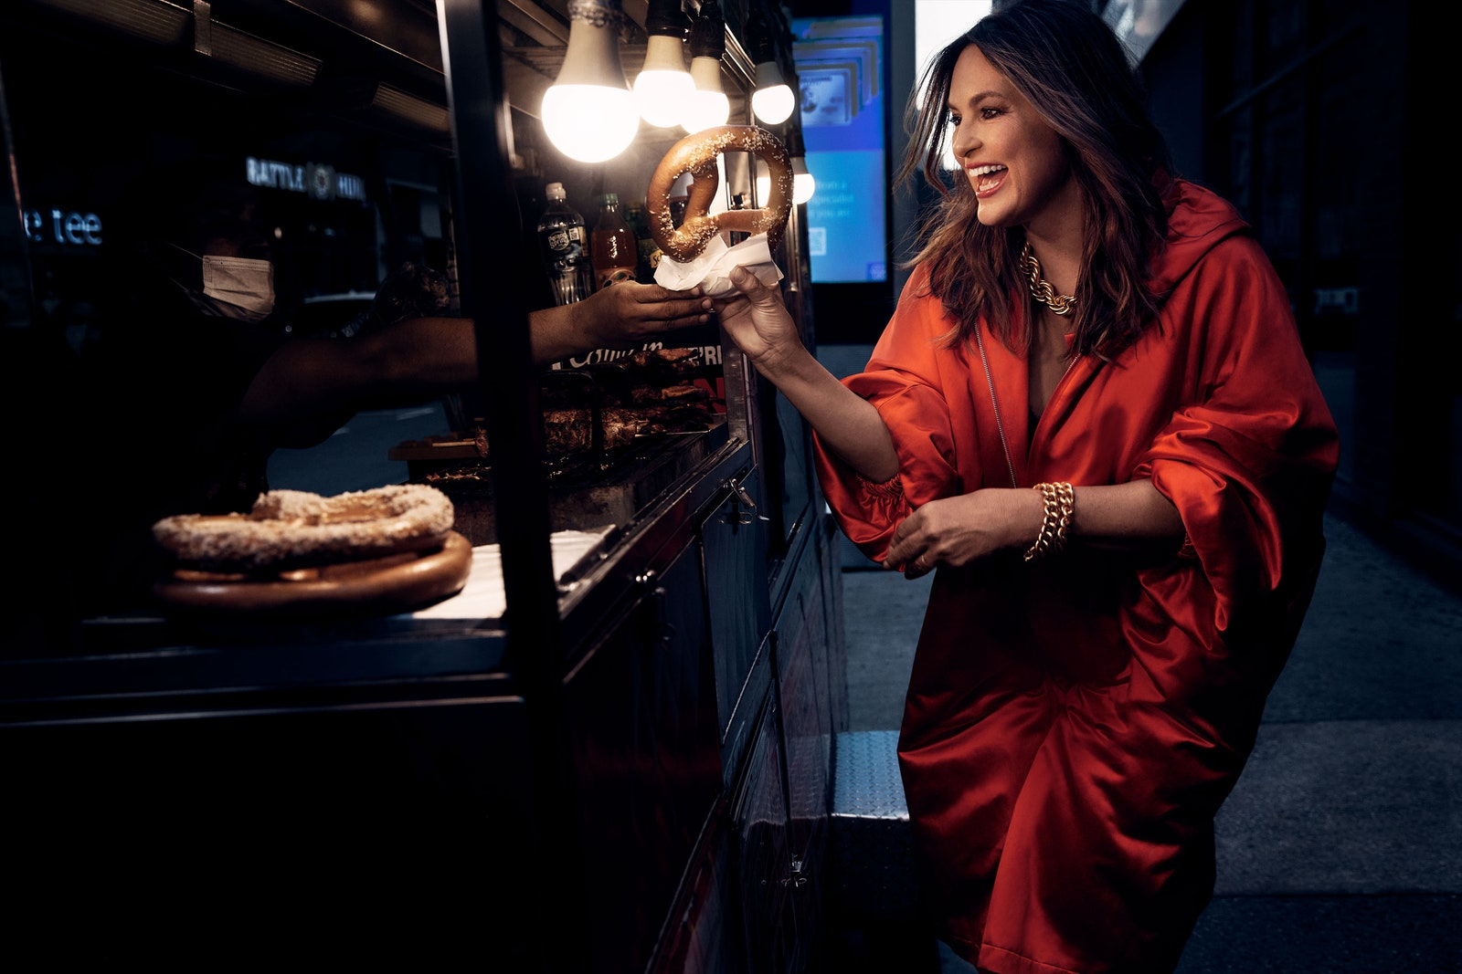

[Dries Van Noten](https://driesvannoten-la.com/) coat. [Brinker and Eliza](https://brinkerandeliza.com/collections/necklaces/products/the-showstopper-necklace) necklace. [Liv Ballard](http://livballard.com/) bracelet.

The role suits her. She is a natural leader both on set and at the foundation. She is less adept at being led herself. When Hargitay was 10, she was hit by a car in New York while crossing the street, and she broke her femur. Her father was doing a show, but he was ready to drop all his commitments to rush to be by her side. “And I was like, ‘No, no, no, I’m fine. I’m in the hospital, I’m going to be okay,’” she says. “My husband laughs, because everyone that knows me says that I say, ‘You don’t tell me. *I decide*.’ That’s kind of my shtick.”

ADVERTISEMENT

That same impulse surfaced last spring when she was on vacation with girlfriends in the Tennessee mountains and got a little off track on a hike as the sun was setting. She and the others were nervous about getting lost and started racing in the near dark to get back when Hargitay tripped. Her friend Brooke Shields was with her, icing Hargitay’s inflamed knee and wondering whether she needed to have a doctor look at it.

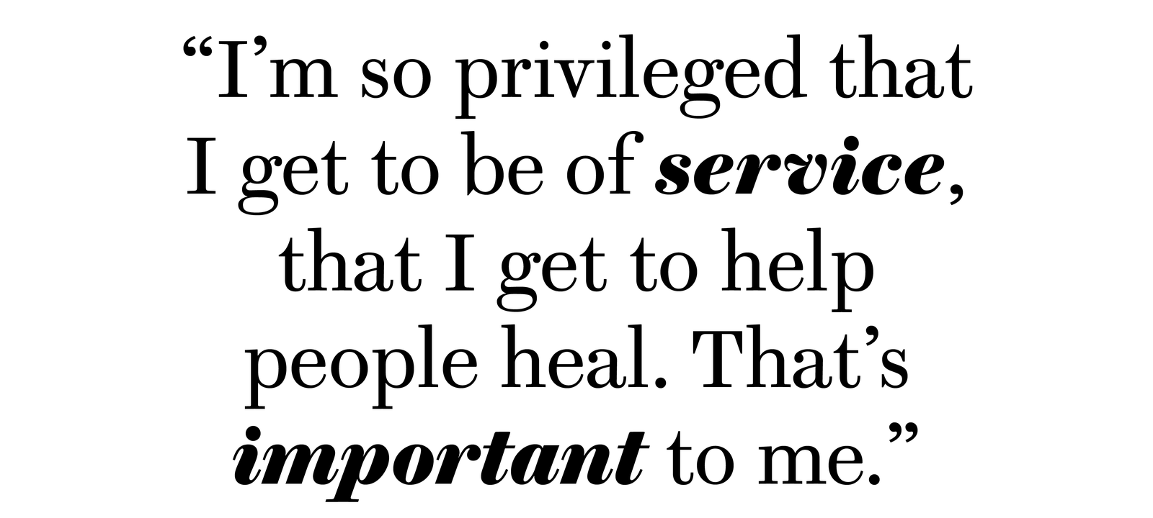

Hargitay ignored it—“I decide”—and flew to L.A., then New York, where she kept pushing through the pain to keep filming. After a couple weeks, she decided to get her knee checked out. The doctor told her it could have collapsed. She would have almost certainly needed surgery. Later that summer she broke her ankle at a Long Island screening of the movie *Black Widow*. All told, she had a broken knee, a hairline fracture in her ankle, and a torn ligament. “It was really rough, four months of hell,” she says. “And I kept saying, as I do about everything, ‘What does this mean? Why is this happening, and what is my responsibility in it?’ And that was the lesson about learning to not push through and to listen to our body. And that’s been a really profound lesson for me—listening to our gut—because that’s our superpower.” So far, the listening-to-her-gut thing? That’s worked out for her.

Shields was there for both accidents and jokes that she must be trying to take Hargitay down. But seriously, Shields says, she’s in awe of how good Hargitay is at her job: “If anything, it gets harder the longer you’re on it. This type of longevity is very rare.” Doing it with so much energy even after all this time would seem to require total focus. But Shields stresses that Hargitay is a relentlessly present friend: “She’s incredibly loyal, and she really makes things important to you a priority. She’s never not available to you, never not the first one to celebrate the women in her life. It’s not about competition; she is a girl’s girl, but she doesn’t compete with her girlfriends. And she can hang with the husbands and be hysterical. She can *banter*.”

ADVERTISEMENT



[Ulla Johnson](https://www.theyes.com/pl/ulla-johnson/dress/francoise-gown-in-fir?utm_campaign=12994850851&utm_source=google&utm_medium=adwords&utm_content=527263872373&utm_term=&adgroupid=121344896537&product_id=d75f588990874a00bed5736eacecd345-5&gclid=Cj0KCQjwtrSLBhCLARIsACh6RmiWgx143qbNu6kuJlHS-8lJus3Qw_E7Fb3XdnKztAt_FpPQGb8FAKYaAoUBEALw_wcB) gown. [Panconesi](https://marcopanconesi.com/) earrings. [Emilio Cavallini](https://www.emiliocavallini.com/en) socks. [Manolo Blahnik](https://www.neimanmarcus.com/p/manolo-blahnik-chaos-suede-ankle-strap-sandals-prod220610208?utm_source=google_shopping&ecid=NMCS_GP_NCXX_XXXX_XXXXXXXXXXXXXXXX_XXXXXXXX&gclid=CjwKCAjwn8SLBhAyEiwAHNTJbS_4g9jYC0Heqe17rBh9aYBzWTyd3pdCZZvW65TS-oxzllz9Rcq2EhoCYQ4QAvD_BwE&gclsrc=aw.ds) heels.

Hargitay’s *SVU* schedule has her filming one new episode every eight days while she’s in production. As of last month, she has done that 500 times. She grew up on the show. It’s where she met her husband. It’s also where she met her former costar and current internet boyfriend Christopher Meloni for the first time. (He left the show after 12 seasons over a contract dispute. Nearly a decade later he returned to the fold for a crossover event for *SVU* to launch his new show, *Law & Order: Organized Crime*.) She describes their dynamic on the show as mother and father. She is the mom who is all heart and emotion and a lioness who’ll defend you. And Meloni, well, “He was the angry father that will fix it at all costs.”

The first time they met, she mistook him for the *Mad Men* actor John Slattery at his audition. “I said, ‘Slattery!’ He goes, ‘Meloni!’” He took it in stride. Meloni is so confident in himself and his work that at that first audition, he was in the process of telling her a story when they walked into a room full of network executives. He told them to hang on for a minute while he finished.

“He’s a bull. He’s intellectual. He’s clear. He’s focused. He’s funny. He’s a ballbuster. And to see him back stronger, faster—he’s like the bionic man,” she says. “He’s like this 60-year-old superhero who is even more dedicated, more badass, more pure, stronger, more focused. He’s just more of everything that he was.”

That kind of heaping praise? That happens a lot in conversation with Hargitay. She’s admiring of *Law & Order* creator Dick Wolf; its longest-running franchise is about sexual trauma. She gives credit to the nameless survivors who attend Joyful Heart retreats. She’s so grateful to her crew, her costars. “She walks the walk and she talks the talk,” says Meloni. “She’s a force for good at whatever she does, whether it’s being a mother or being an advocate or being an actress or being a friend.”

ADVERTISEMENT

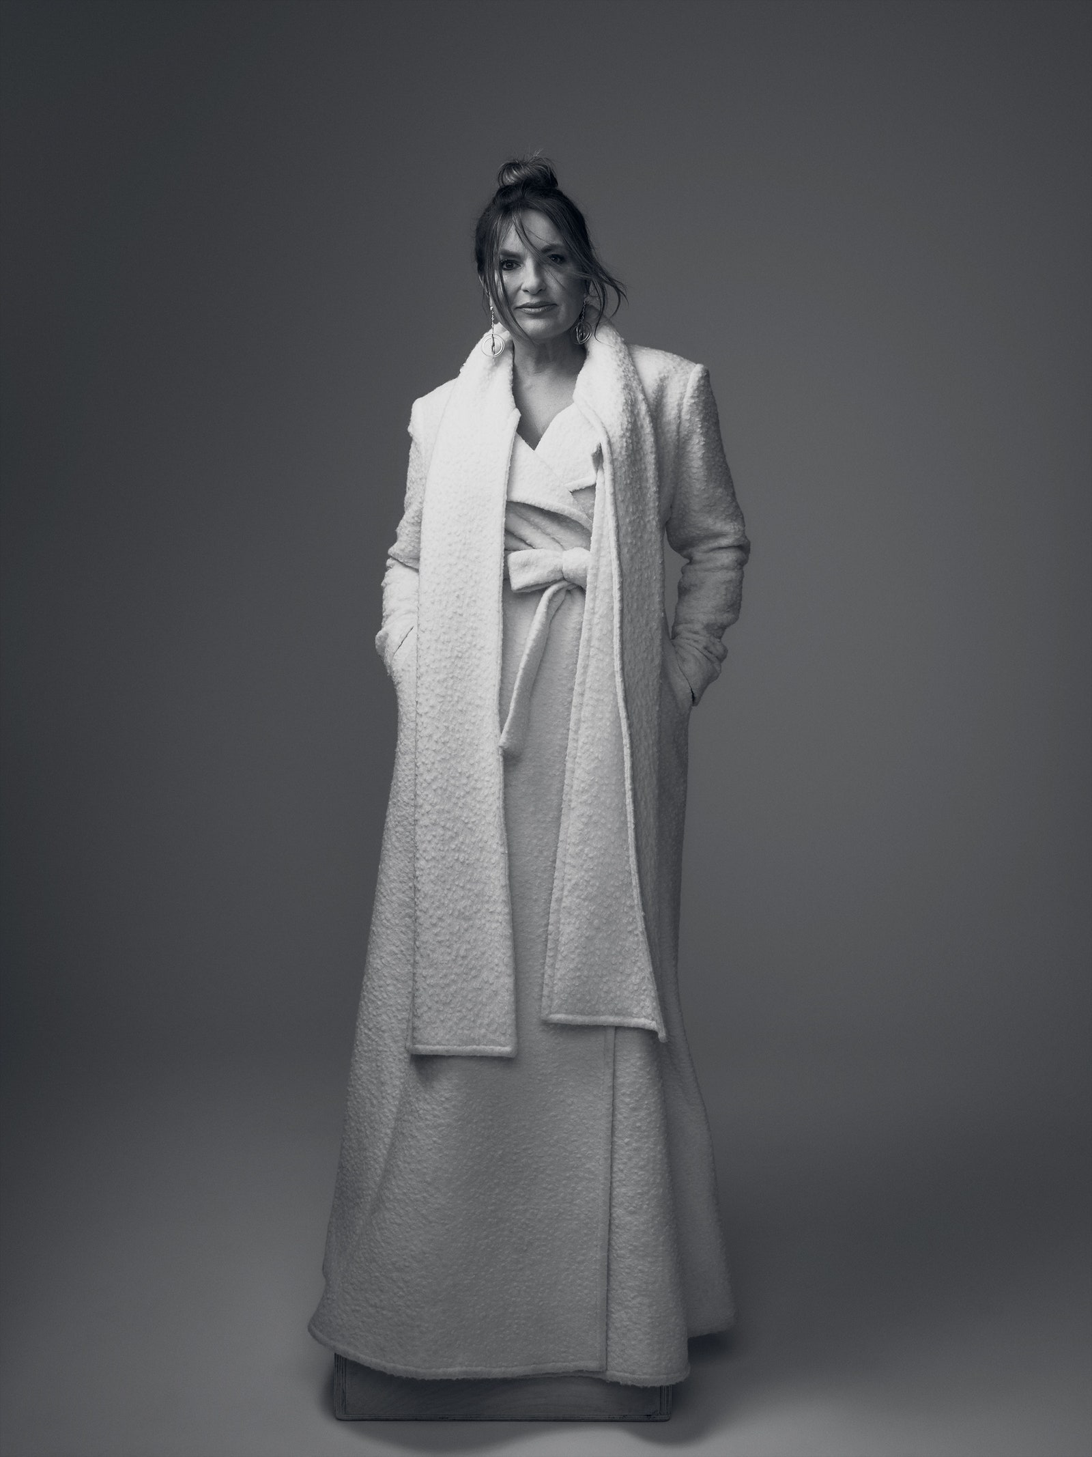

[Christian Siriano](https://christiansiriano.com/collections/fall-2021/products/look-1) coat. [Liv Ballard](http://livballard.com/) earrings.

So does she feel like she gets her due as an actor, as a powerhouse, as a successful woman, as an activist? “Do I get my due?” she repeats, choking up. “Yes, I do because I’m so privileged that I get to do it, that I get to find my purpose, that I get to be of service, that I get to help people heal. That’s what I know. That’s important to me.”

Which is not to say that she’s done or that, with 500 episodes behind her, it’s all nostalgia and kicking back. She started out in sitcoms, and she’d like to get people laughing again. “My personality is very different from Olivia Benson,” she says. “I like to laugh…. I like to make my kids laugh. And comedy has a real currency in our household.” She has been considering writing a book for a long time.

She has advice she’d like to share and lots of dark, hilarious, sometimes emotional stories to tell. “People ask you that question, ‘What would you say to your younger self?’ And I think for me, I would have grabbed that little girl’s hand and said, ‘Everything is going to be okay. Trust me. Trust me. Everything’s going to be okay.’” From someone else—especially from another beautiful, successful actor—that might sound like a bland platitude, but Hargitay has worked hard for the perspective she has. Her life, she declares, “has been a journey in healing.”

So what has she learned about how the process works? Is it a matter of just waiting things out? Or is it having a spiritual practice? Doing inner work? She nods and smiles. “I think the answer is E, all of the above.”

*Marisa Meltzer is a writer based in New York. She is the author of* This Is Big: How the Founder of Weight Watchers Changed the World (and Me)*.*

**Photographed by Victoria Will; styled by Jordan LaValle and Meg Chapman; hair by Mia Santiago; makeup by Jeanine Lobell.**